Lab 02 Logic Components

Luis Echegaray

7/13/2014

Second Summer 2014

Purpose:

The purpose of this lab is to create a 4-bit shifter which can handle no shift, left shit, and right shift. For the purpose of this lab we do not implement rotate right, instead we make it a no shift. Shifters are used in multiplication and dividing binary numbers.

Analysis:

The building blocks for the shifter we must implement are the one variable and two variable mux we implemented in the last lab period.

S0 & S1 represent the different cases we must perform: NO SHIFT (00/11), SHIFT LEFT (01), and SHIFT RIGHT(10). SRIN is when the input if shifting right and SLIN is for when the input is shifting left. Likewise with SLOUT meaning output when shifting left and SROUT meaning output when shifting right.

Now I am running out of time to finish the analysis completely! I had some computer problems and got behind.

4-bit expandable shifter Symbol

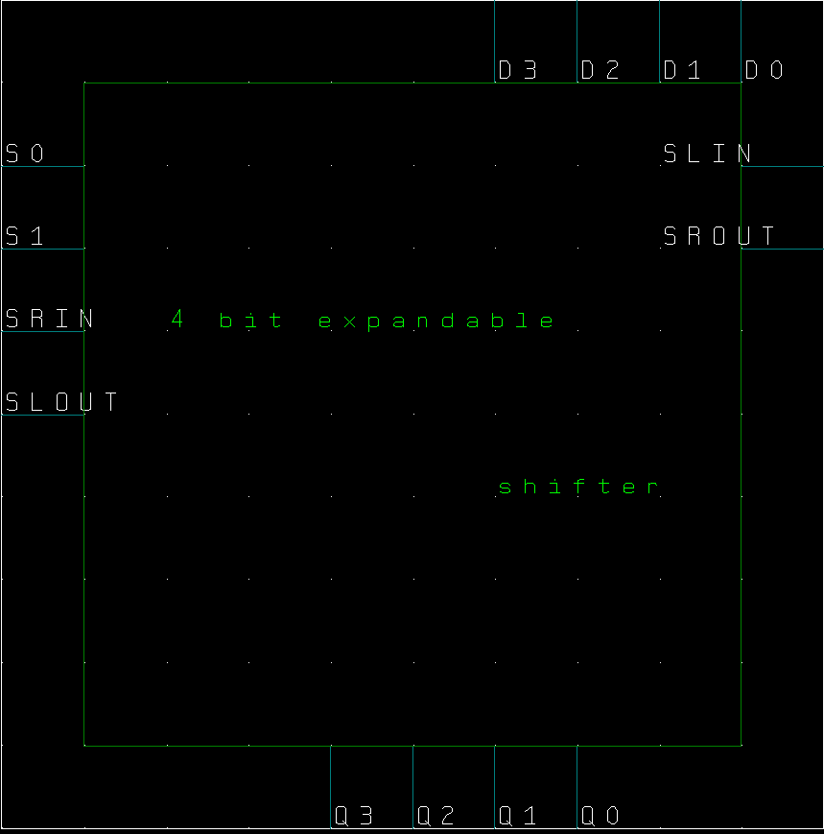

4-bit expandable shifter Schematic

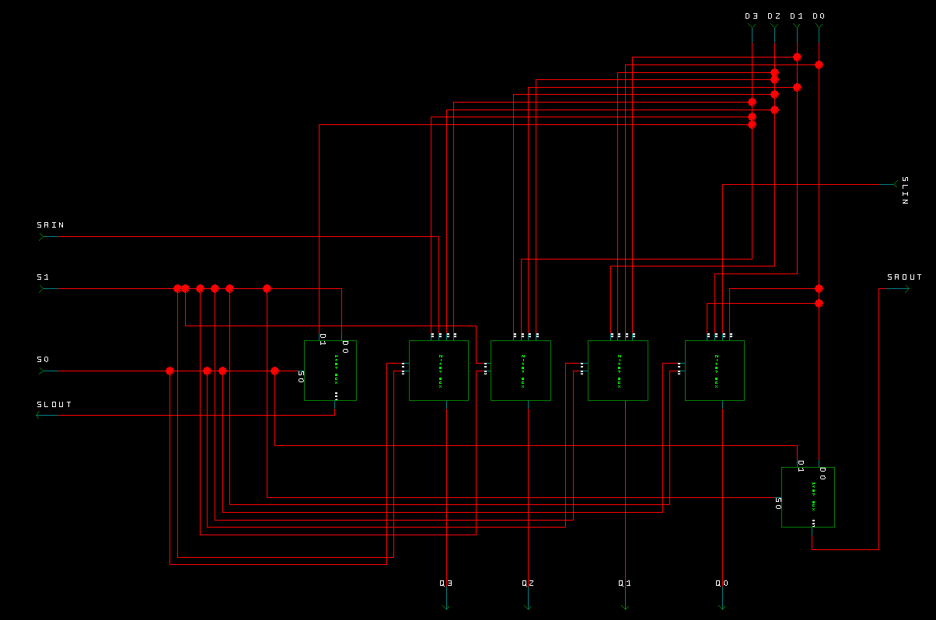

4-bit expandable shifter Command File

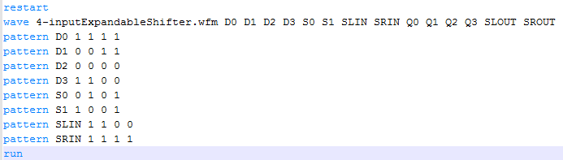

Expected Resullts

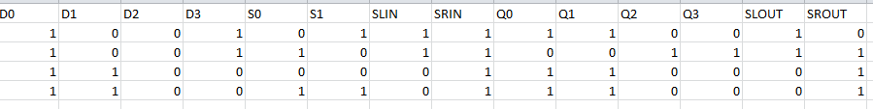

Simulation Screenshot with Motorola(real) components

